# Assignment 1

## Task 1

### Portrait

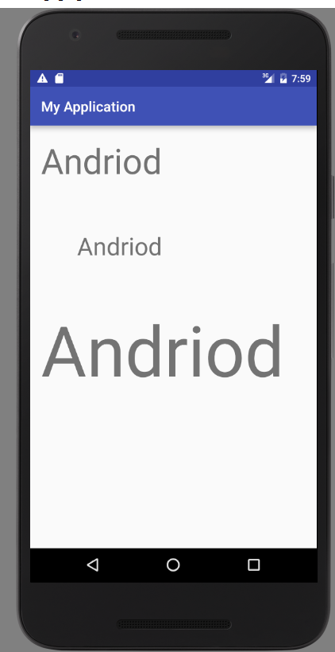

### Landscape

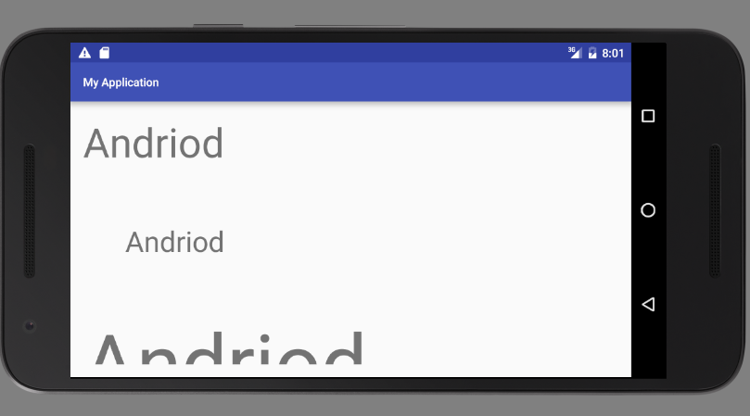

## Task 2

There are 3 key differences between a pc and a mobile device operating systems are:

1. Screen size and orientation

A mobile devices come in all different shapes and sizes ranging from 3- 6 inch screens. The operating system must be able to adjust to this and display the apps evenly no different to a normal pc, but some devices can be viewed in either portrait or landscape. This requires the device to a leveller inside it and whenever it reaches a certain point the device will change the screen orientation (if the app or device has a rotation block on it).

1. User input

A mobile device has a keyboard which is touch screen which appears when you select a text box or if you select a drop down box you will be able to slide down with your finger and then select an object by pressing your finger on it. If you want to select an app all you do is press it with your finger. So basically you need your trusty finger to use a mobile device. Some do allow you to use other objects but some screens are heat sensitive so you might have to activate a setting to allow foreign objects to operate any user input.

1. Cellular data

A mobile device must allow the use of cellular data so people can send and receive phone calls and text messages. The device has the ability to pause current apps when you answer the phone and then unpause if you wish to continue using the app while talking or when you finish talking.

## Task 3

### MDPI – 160dpi

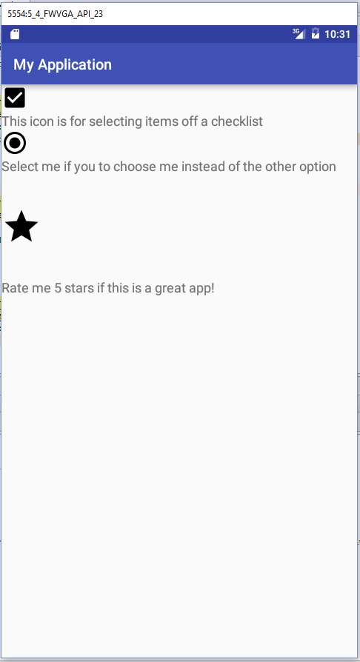

### HDPI – 240dpi

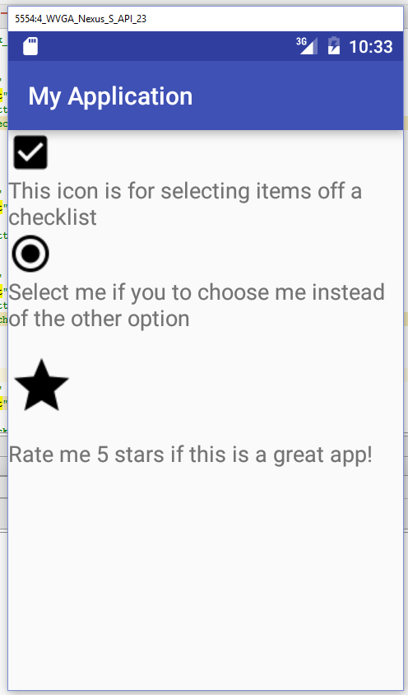

### XHDPI

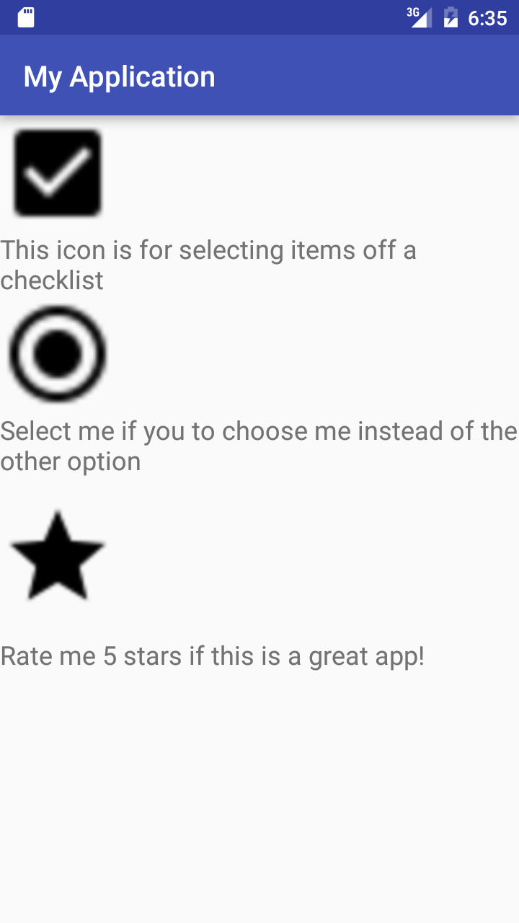

The reason why this isn’t ideal because the low res phone has a smaller dpi. So when a high res phone loads the image, it will become pixelated and the image will not look good.

## Task 4

Separation of concerns is a design principle. This basically means separating distinct sections of the program and bundle relevant information structures together. A good example would be the MVC method of object orientated programing. This separates the program into three sections. The Model is data structure of the program. The View is the design layout of each screen. The Controller holds all the functionality of the program which bridges the communication gap between the model and the view. This helps with UI design because you are able to create a pages and separate the functionality. This helps you update, test and debug code so you aren’t looking through a clutter of code.

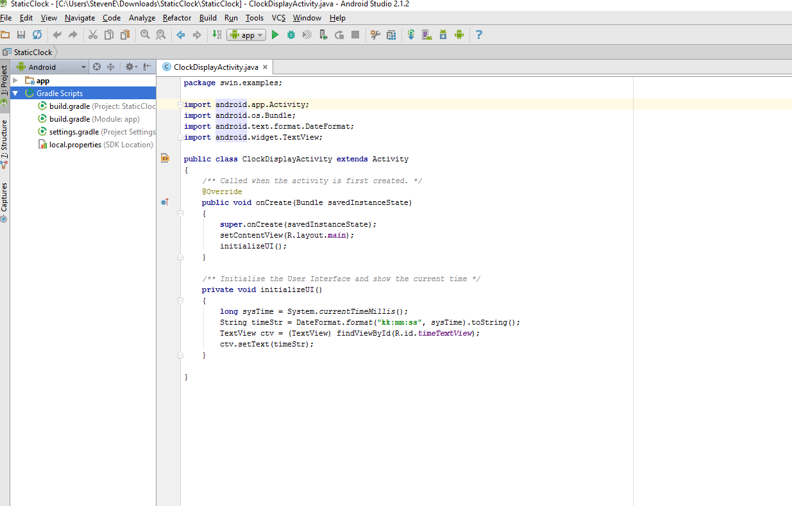

This is an example of a Controller which has all the functionality in it. As you can see by having the Controller outside of a View you can easily manipulate the View by connecting eachother by added id’s to each element and assignment them to variables.

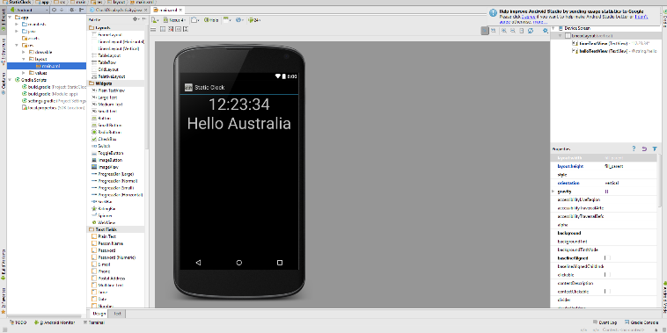This is an example of a View which has all the only design of the app. As you see this has an image of an app and on the left we are able to add functionally by dragging items into the View and placing them. On the right we have the properties of the element which you can update once you click on them.